Nama : iga auliani

1. Select id , transaction.id_pelanggan , customer.nama_pelanggan, kelurahan from ‘transaction’ join customer on transaction.id_pelanggan = customer.id_pelanggan where kelurahan like ‘%pekayon%’ order by id_pelanggan asc

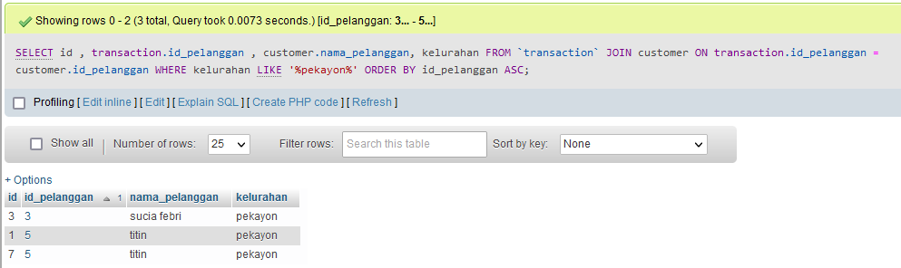

1. 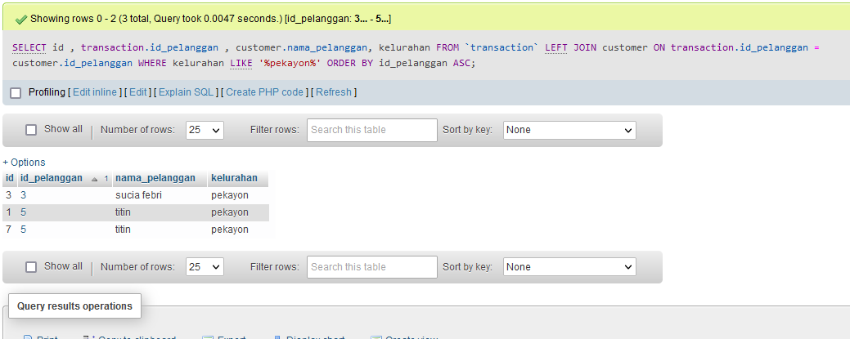Select id , transaction.id_pelanggan , customer.nama_pelanggan, kelurahan from ‘transaction’ left join customer transaction.id_pelanggan = customer.id_pelanggan where kelurahan like ‘%pekayon%’ order by id_pelanggan ASC
2. Select id , transaction.id_pelanggan , customer.nama_pelanggan, kelurahan from ‘transaction’ left join customer transaction.id_pelanggan = customer.id_pelanggan where kelurahan like ‘%pekayon%’ AND no_tlpn is null order by id_pelanggan asc

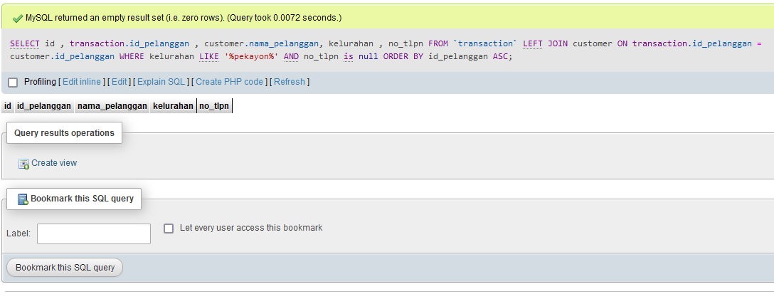

1. Select id , transaction.id_pelanggan , customer.nama_pelanggan, kelurahan from ‘transaction’ right join customer transaction.id_pelanggan = customer.id_pelanggan where kelurahan like ‘%pekayon%’ order by id_pelanggan asc

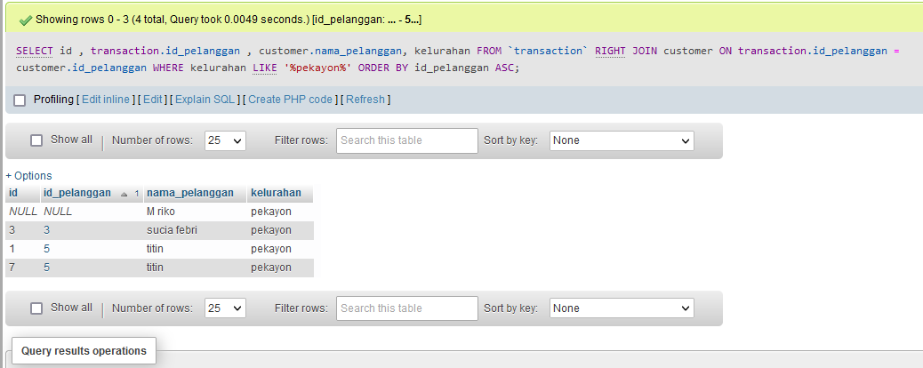

Select id , transaction.id_pelanggan , customer.nama_pelanggan, kelurahan from ‘transaction’ join customer transaction.id_pelanggan = customer.id_pelanggan where kelurahan like ‘%kalisari%’ and no_tlpn is not null order by id_pelanggan asc

1. 